Test Instruction:

1. Verify that the files are put in the correct folder:

Go to any web browser, and type localhost in the search bar:

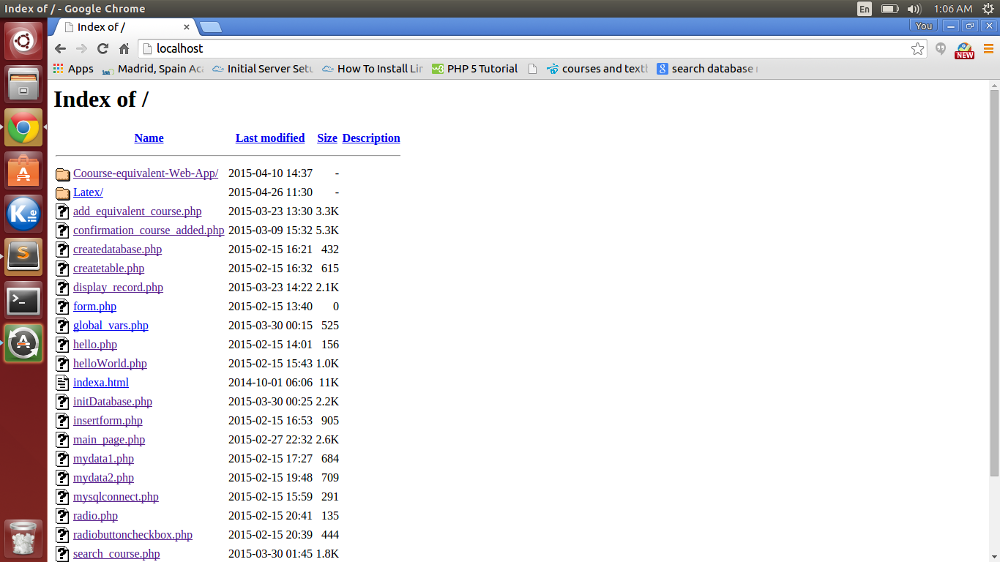

If you can see the file folder (The folder should be named as something like Course-equivalent-Web-App/), that means the folder is in the correct path!

2. Verify the database:

Now open the folder,

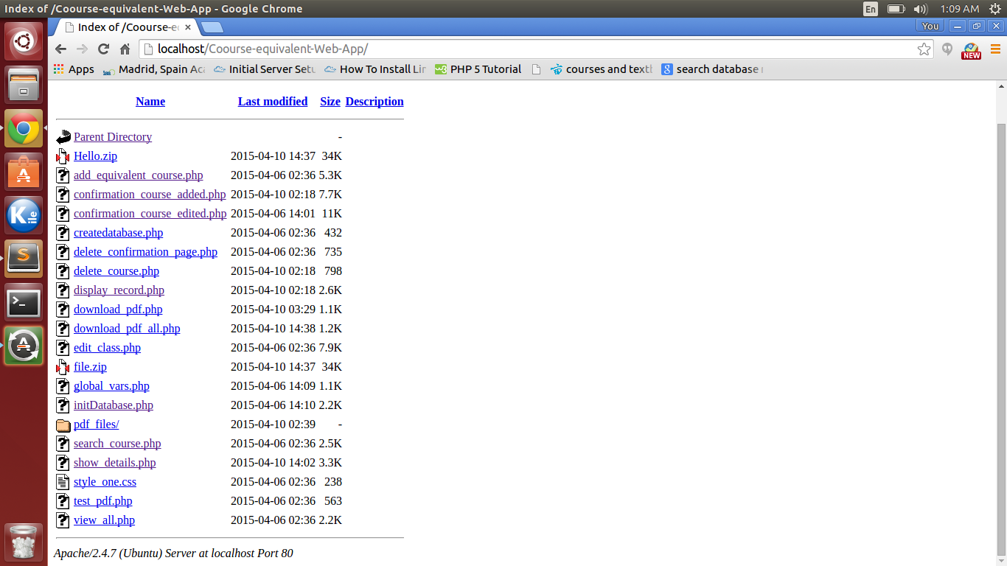

and you can see several files in there.

Click on the initDatabase.php file and if you see a page like the following, you successfully created the new database!

NOTE: Do not click on the file once the database is created. Otherwise everything will be erased and the database will be empty.

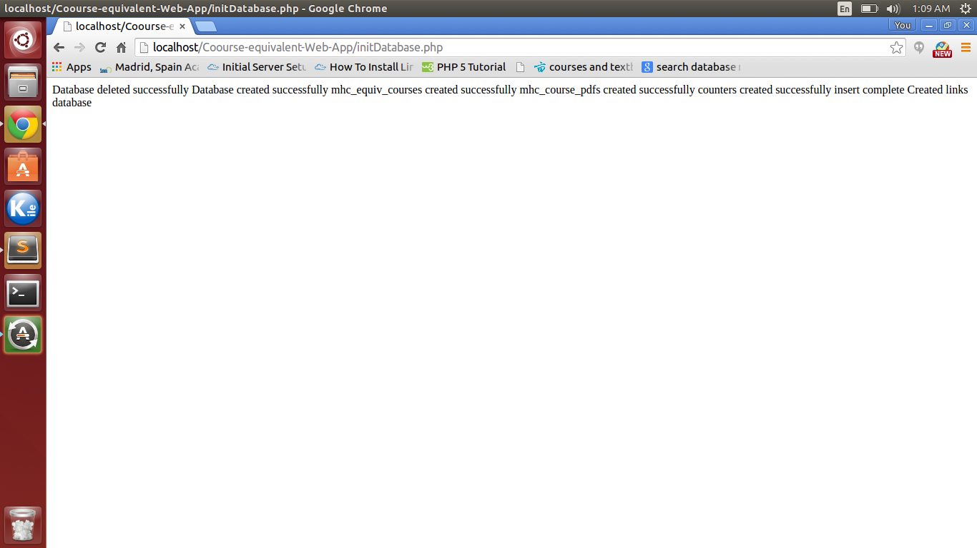

If the page shows something else, test to see if the database has the right username and password. (Refer to the installation instruction)

3. Verify add course is working:

Go to localhost again, and go to the folder. Click on file add_equivalent_course.php. You should see a page like the following:

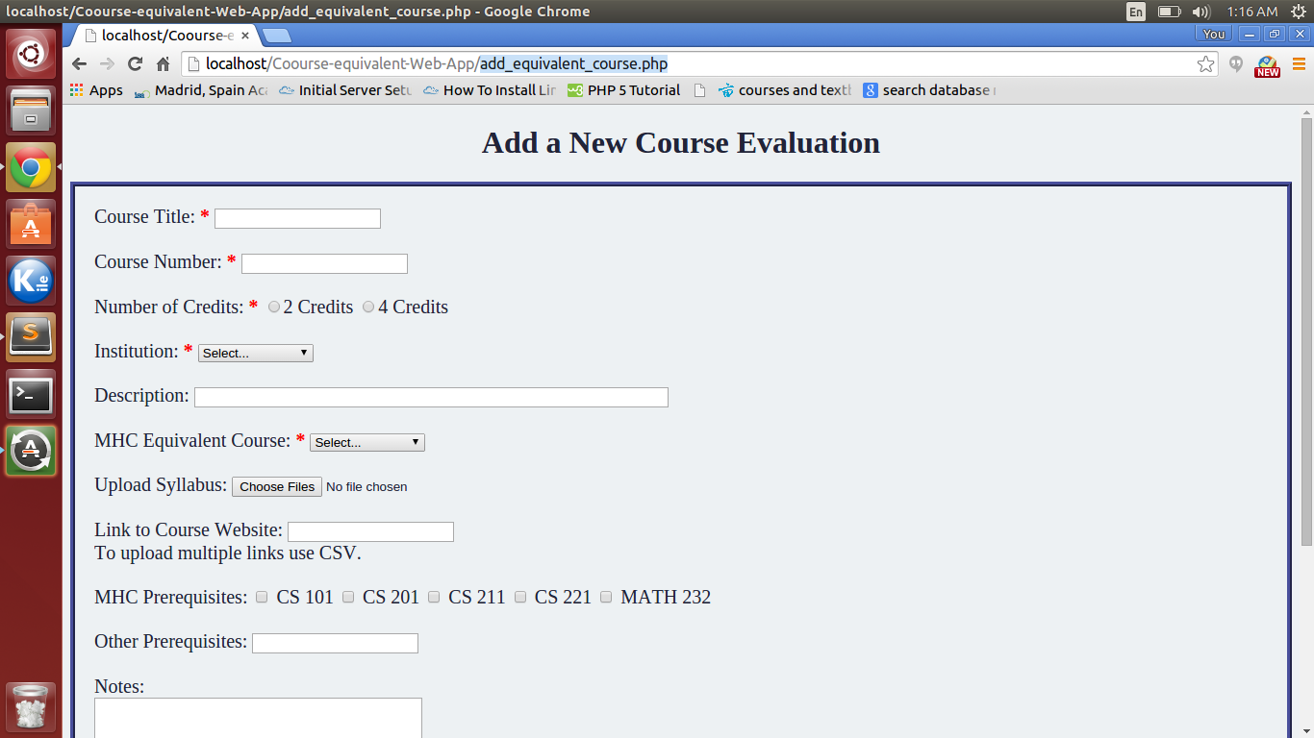

Try to have a class added, here is an example of a class that I added(also do not put any "'" in because that may mess up the database):

Course title: Data Mining

Course number: CS321

Number of credits: 4

Institution: Amherst

Description: This is a 300-level class

MHC Equivalent Course: CS 300 elective

Upload Syllabus: choose any pdf files. My file is called PS4.pdf

Link to Course Website: www.google.com

MHC Prerequisites: CS101 CS201 CS221

Other Prerequisites: MATH221

Notes: This course is offered every other year

Professor approving: Alice

Course approved: yes(click on the button)

Now you can click on save to save the course in the database.

You should see a confirmation page like this:

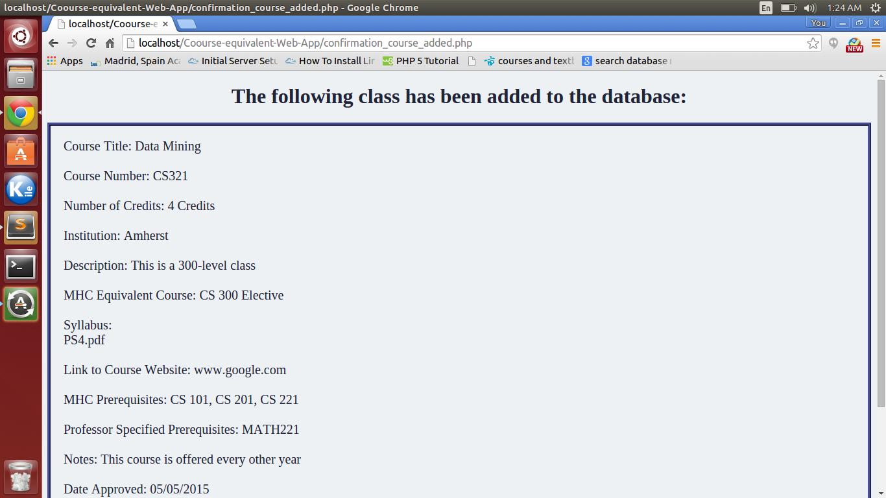

Congratulations, you have added the course sucessfully!

4. Test search page:

Go back to the folder and click on search_course.php, a page like the following will show up:

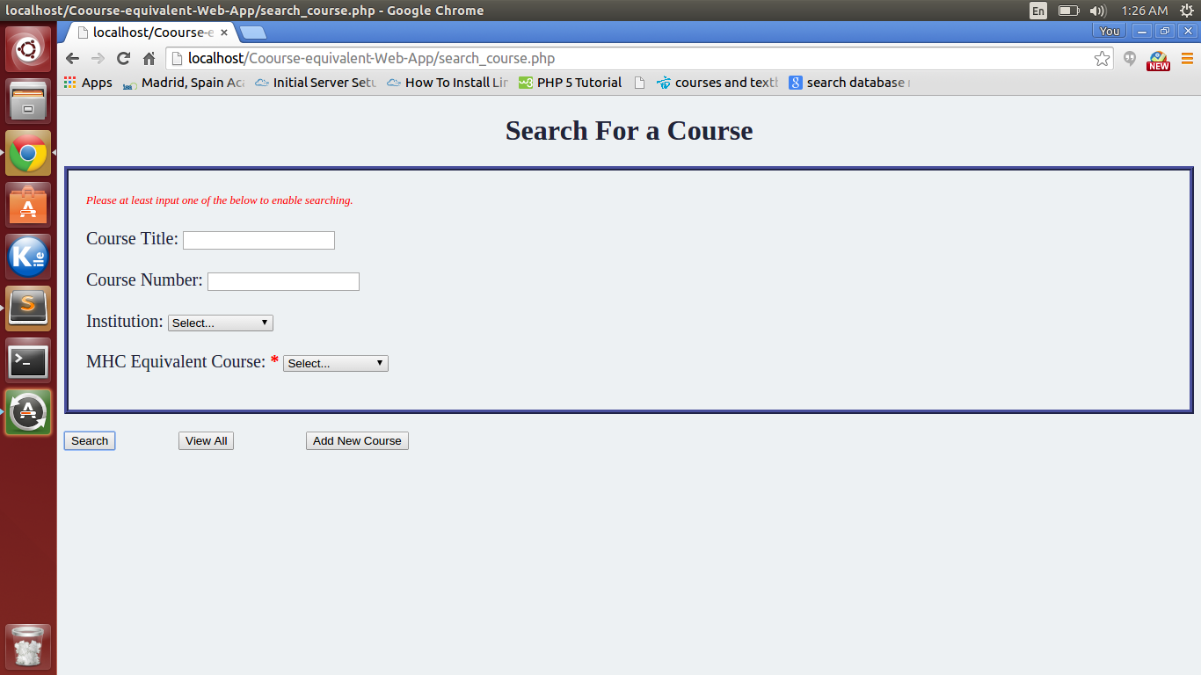

You can click on "view all" button to check if you have the one course you added before.

And then come back and fill in any of the criteria to enable searching. My "view all" looks like this:

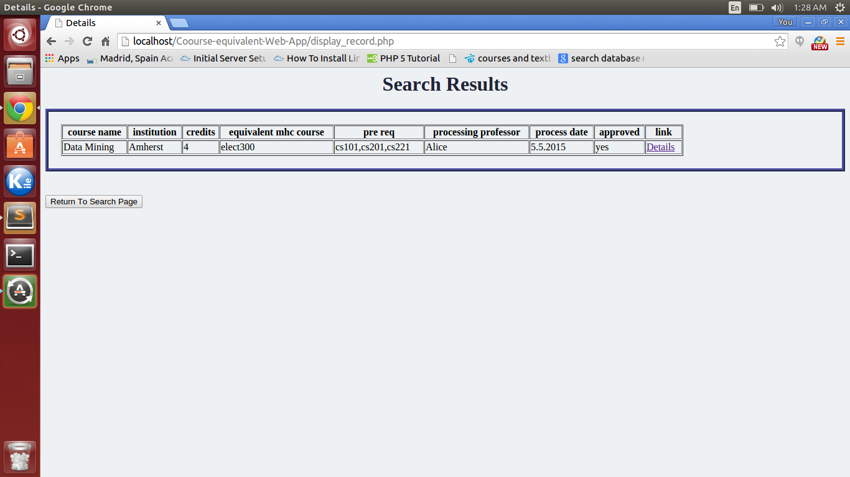

Now click on the "Details" below the link column and you will see something like this:

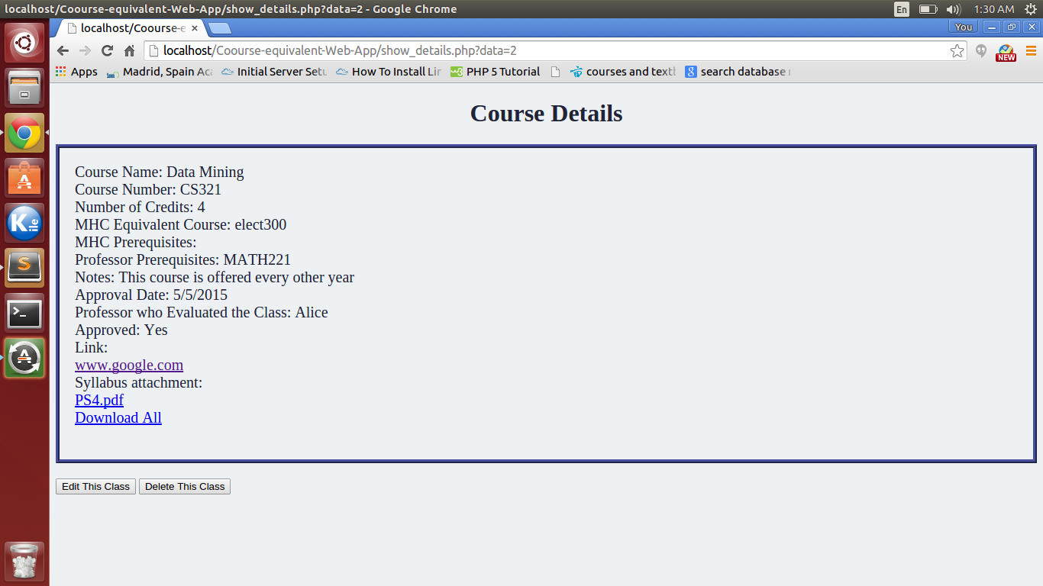

You should be able to click on the course link to open the page in a new tab/

You can also click on the file name to download one of them or click on download all to download a .zip file.

Please open the file being downloaded to make sure it is the right file and not invalid.

5. Test edit page:

Click on the button "Edit This Class" to edit the class. Change anything you want. I changed my "MHC Equivalent Course" from "CS 300 elective" to "CS201", and then click on "save" again:

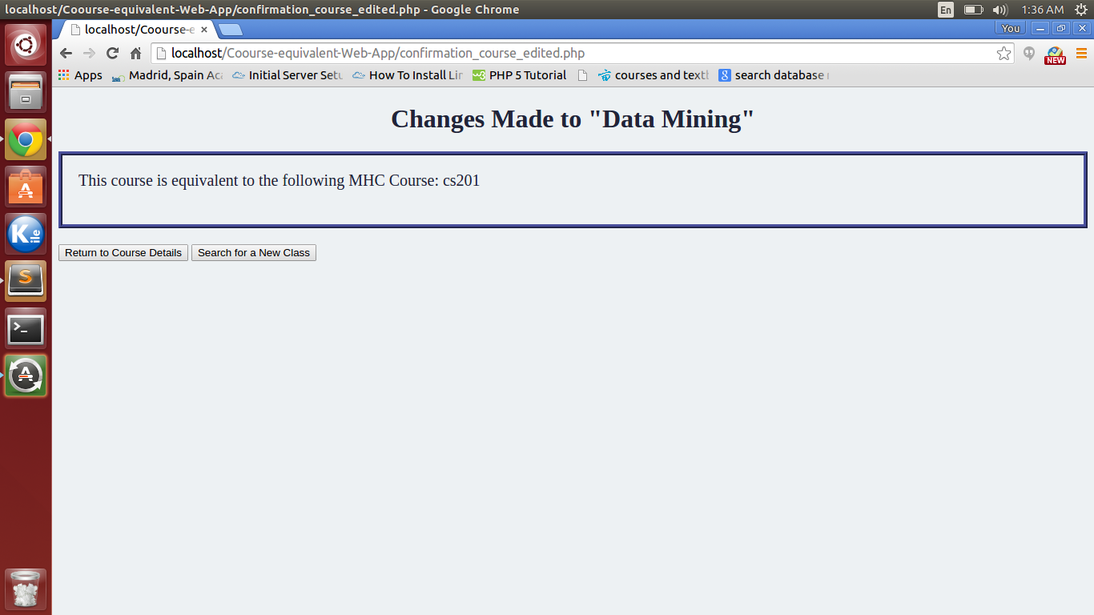

You will see a list of things that you have made changes.

6. Test delete course:

Click on the button "Return To Course Details", and click on the button "Delete This Class". You should see a confirmation page:

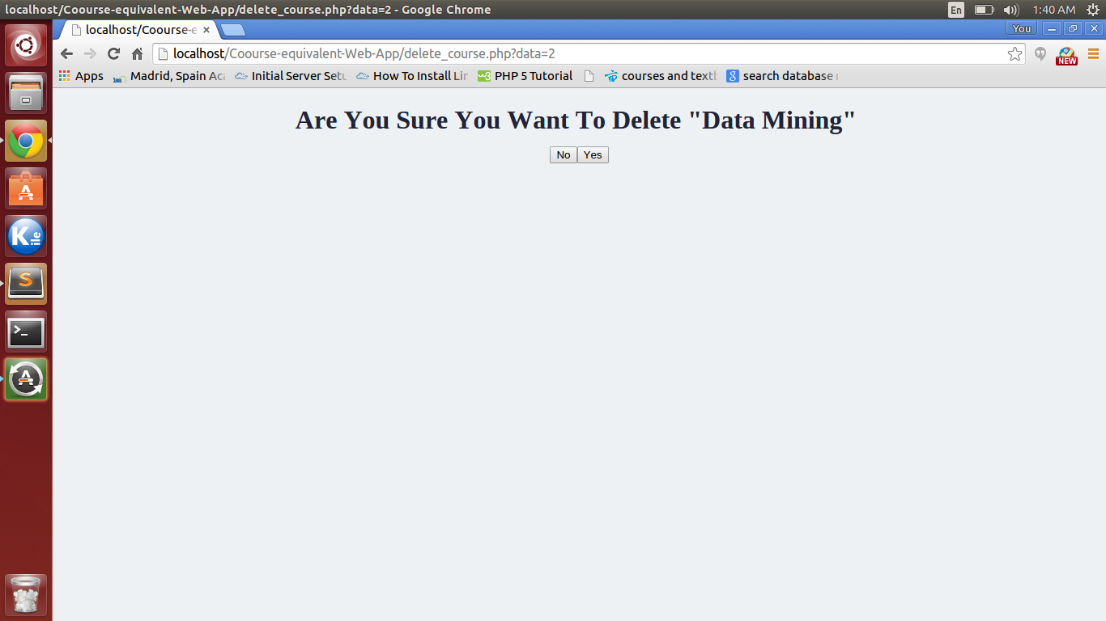

Click on "yes", a new page stating your class is deleted will show up. Click on the button "Return to Search Page" and "view all" to make sure that the class is deleted.

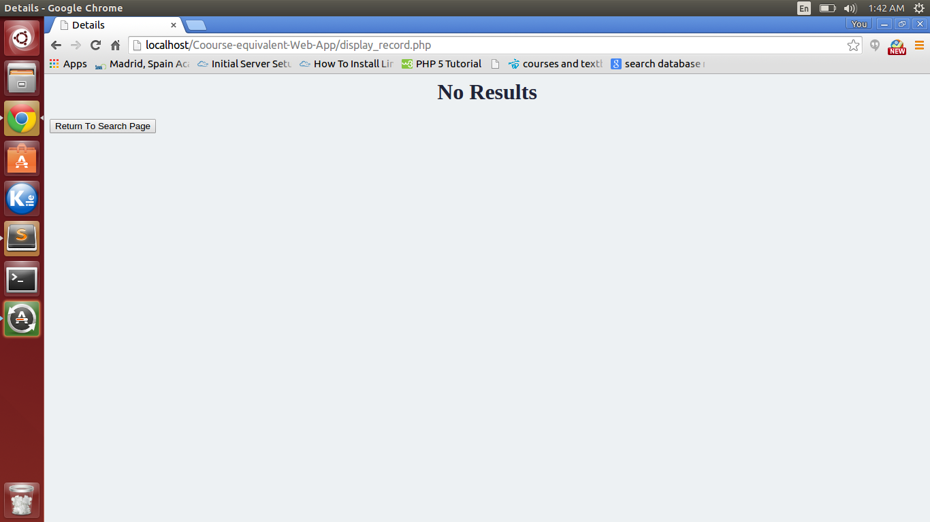

ENJOY!